**JANUARY SALES**

select count (Sales_January_2019$.[QuantityOrdered]) as OrderedQuantity,

Sales_January_2019$.Product,

sum (Sales_January_2019$.[QuantityOrdered]) * Sales_January_2019$.PriceEach as TotalSales

From Sales_January_2019$

where Sales_January_2019$.[QuantityOrdered] is not null

Group by Product,Sales_January_2019$.[PriceEach]

**TOP SALES**

select count (Sales_January_2019$.[QuantityOrdered]) as OrderedQuantity,

Sales_January_2019$.Product,

sum (Sales_January_2019$.[QuantityOrdered]) * Sales_January_2019$.PriceEach as TotalSales

From Sales_January_2019$

where Sales_January_2019$.[QuantityOrdered] is not null

Group by Product,Sales_January_2019$.[PriceEach]

order by TotalSales desc

**Status of Sales using USED CASE**

select count (Sales_January_2019$.[QuantityOrdered]) as OrderedQuantity,

Sales_January_2019$.Product,

sum (Sales_January_2019$.[QuantityOrdered]) * Sales_January_2019$.PriceEach as TotalSales,

case

when sum (Sales_January_2019$.[QuantityOrdered]) * Sales_January_2019$.PriceEach > 20000 then 'Qouta Reached'

else 'Qouta Not Reached'

end as SalesStatus

From Sales_January_2019$

where Sales_January_2019$.[QuantityOrdered] is not null

Group by Product,Sales_January_2019$.[PriceEach]

order by TotalSales desc

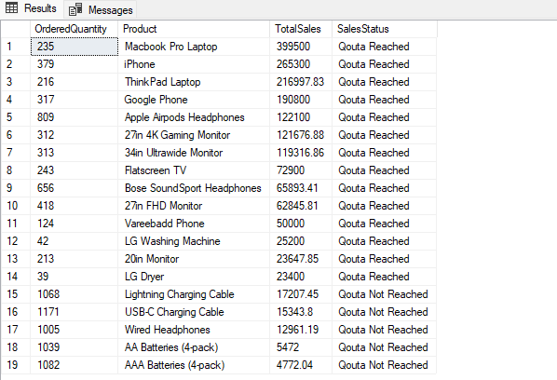

**NUMBER OF PRODUCTS SOLD IN TWO YEARS**

Select b.Product, Count(1) AS Number_Of_Products

From Sales_January_2019$ as a

INNER JOIN Sales_February_2019$ as b

on b.Product = a.Product

GROUP BY b.Product

Select b.Product, Count(1) AS Number_Of_Products,

sum(b.QuantityOrdered + a.QuantityOrdered ) AS Number_Of_Orders

From Sales_January_2019$ as a

INNER JOIN Sales_February_2019$ as b

on a.Product = b.Product

where b.QuantityOrdered is not null

GROUP BY b.Product

